**CARBON MARKETS HQ REPORTS**

1. Maximum number of Credits issued in 2021 where the mean of issuance 653

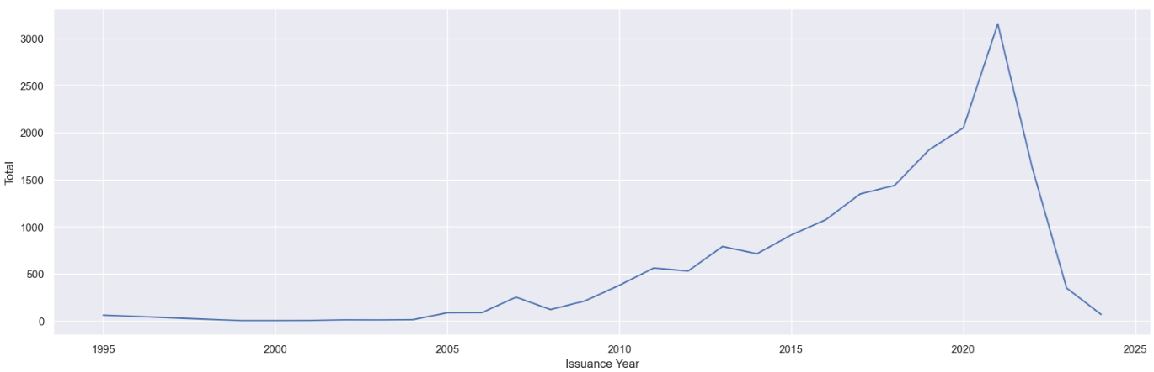

1. Maximum number of Credits issued in 2020 where the mean of retirement 935

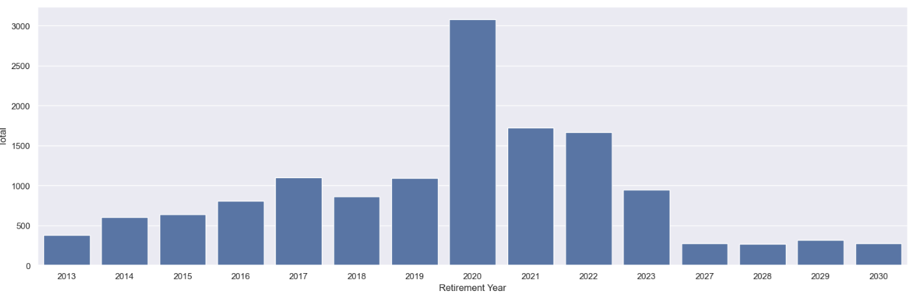

1. Top 5 Project Types

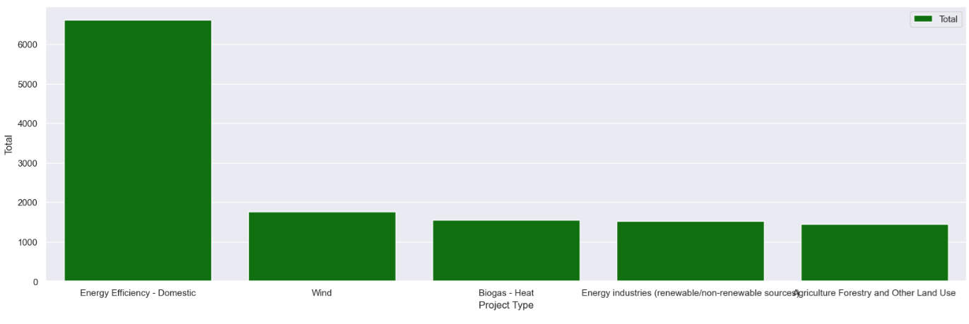

1. Top countries by Projects Developed

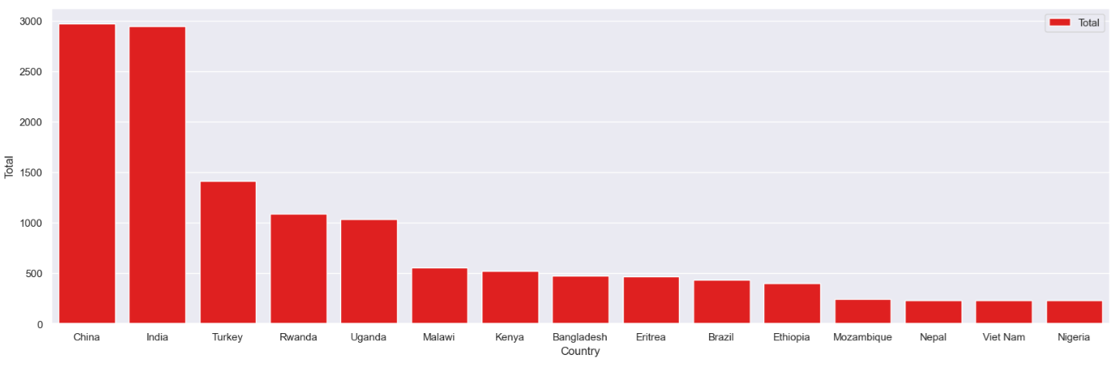

1. Top Project Developers

